Lives Not Knives
A church response
Introduction
Serious violence involving young people is killing young people in our city. We cannot stand by. We cannot walk on the other side of the street. We are called to act.
The story of the Good Samaritan teaches us how to be good neighbours. The priest and Levite cross on the opposite side from the injured man. It takes the outsider, the stranger, the Samaritan to act. We cannot be the priest or the Levite. We must become the outsider, the stranger. This is not about ethnicity or faith; this is about young people. We must stand together. We have to heal wounds, care for those affected, strive to be part of the solution and challenge the root cause – poverty.
The good neighbour is not a passive role and it is not an easy option. However, it is something we must do to end violence on the streets of our city.
How can you help?
We are asking every church in the City to promote awareness of knife and violent crime, if possible on Sunday 14th July or on another Sunday this summer. The attached pack has five sections of resources to help you plan your response:
Raising awareness – through our services – providing liturgy, service ideas, activity ideas, information, facts and figures
Prayer – prayers for hope, reconciliation and solidarity; prayers at locations where people have been stabbed; prayers for our emergency services
Talk and listen – talk and listen to young people in church, schools, youth groups and uniform groups; build on the Safe Spaces initiative
Challenging the causes – recognising poverty as a root cause; supporting foodbank; volunteer; write to MP
Community action – first aid training, community bleed kits, displaying blue ribbons

Raising Awareness
Service outline – see appendix 1
Background facts and figures
West Midlands Police is the second largest police force in the country, covering an area of 348 square miles and serving a population of almost 2.6 million people.
 | Violent crime | Possession of weapons
Sept 2018 | 6884 | 212
Sept 2017 | 4990 | 235
Sept 2016 | 4511 | 130
Sept 2015 | 3792 | 97
Sept 2014 | 3356 | 97
Sept 2013 | 2912 | 106
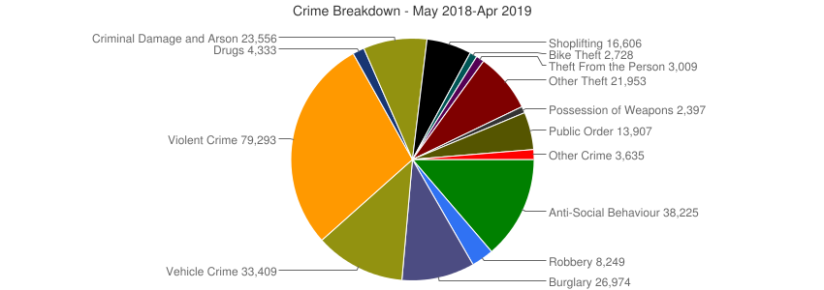

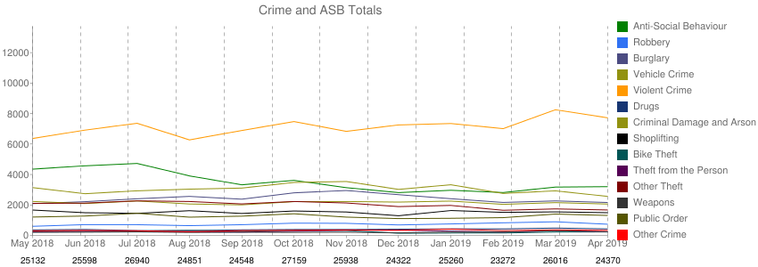

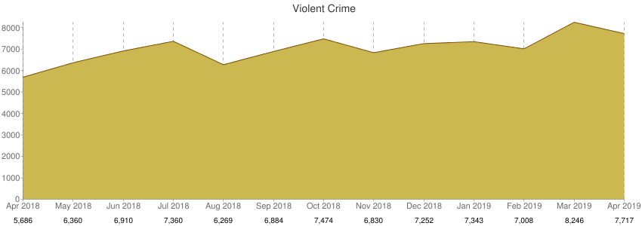

Reflections
The following reflections are offered for use in services or to aid your thought process.

Lives not knives could racism have anything to do with it? By Rev Douglas Machiridza, St Andrew‘s church, Handsworth, Birmingham.
I work and live in Handsworth, a very diverse but also a place that is very challenged with respect to resources and youth and young people‘s aspirations. I know people talk a lot about a youth culture that is so pervasive and devoid of morality and the like, which it is assumed is one of the causes of this seemingly epidemic that appears to engulf our cities and towns.
Wearing my social scientist hat as I used to be a social worker and a student of social sciences before becoming a priest in the church of God. I have always wondered why is that there are more ethnic minority young people who are affected by this scourge than the other set of young people? Without being too ‘glib’ about it either , why is it that if you look and analyse the knives and gun crime episodes, when black youth or young persons are involved , the media coverage appears to be different than when it’s a white youth or young person involved?.
It would appear that, the parents and relatives of the white victims of knives and gun crime get a better media coverage with press conferences hastily arranged and Trusts set up in honour of the deceased ‘s names immediately after the incidences. Where as in the converse, the parents and relatives of black on black knives’ and gun crimes do not seem to get a look in and instead it would appear that from the onset the narrative is more of blame than of sympathy, regret or sorrow.
Could it then be or can we safely suggest that part of the problem is racism and how the society automatically think and send messages that ‘Black Lives do not Matter’. We all know the social science statistics that black boys are 10 times more likely to develop serious mental health issues in their lives than their white counter parts and that black men are 4 times more likely to be admitted into metal health institutions than their white counterparts.
We also have heard of the statistics that more black boys and men are more likely to be stopped and searched by the police than any other racial group. As we recite and hear these statistics, what then comes to our minds and to the minds of the young black boys and men is the message, ‘ that Black lives do not matter’. And society is not doing anything tangible to dispel and interrogate that message, I have a son, a young black boy who is 8 years old and very soon he will be in secondary school, where he will begin to encounter and hear the negative narratives that are bounded around and I fear very much. I fear that he will internalise the message that he is a threat to society and that he would amount to nothing. And when that happens he will internalise that fear and then seek to protect himself by any means necessarily, which inevitably will lead him to carry a knife around for protection and when that happens there is trouble in paradise.
The Good Samaritan by Rev Claire Turner Vicar, St Chad’s Rubery

It is said that a good parable should kick us in the guts, shake us up a bit, disturb our often ‘cosy’ interpretation of the world. It should make us think – and do – differently but many of us grow up with a ‘Sunday School’ understanding of the parables which, whilst not wrong, has softened their punch.
This is as true of The Good Samaritan as any other parable – we confidently encourage one another to welcome the stranger, to go to the aid of those who are poor, helpless or alone. We feel good when we do those things and of course, we should do those things – there are all sorts of places in the Bible where we are called to do those things. But – but – does reading the parable in that way really make us uncomfortable? Does it challenge us? Does it shake us up? Does it get us in the gut?
Do we want it to do those things?
The lawyer who asked Jesus the question that led to him telling this story, didn’t want to be made to feel uncomfortable. He knew all the ‘right’ answers, he knew the law, he’d led a good life. I suspect he’d looked after his neighbour, given to charity but the story Jesus’ tells is harder.
It’s harder because at the time, Samaritans weren’t the unknown strangers. They weren’t people that no-one knew or understood. They were the known enemy – they were hated, despised and feared. It is this hated enemy who stops, this despised neighbour who reaches out his hand and offers help. Suddenly, we begin to feel a little less comfortable. Do we still want to be cast in the role of ‘Good Samaritan’?
If not, then perhaps we are being invited to see ourselves as the man on the ground? The person who has been beaten, who has nothing and no-one in their hour of need. Thankfully, many of us haven’t experienced such a thing but we do know what it means to be alone, frightened and hurt. When we are in that place, are we able, as the man in the story did, to look up, see the despised, hated enemy and accept their help?

This is an interesting question to consider when we think about the knife crime epidemic. We can all read about the man on the road and remember those who have tragically and unfairly lost their lives having been stabbed and we can imagine stopping to help someone who had been the victim of such a violent act. But how do we see those who commit such crimes?
Can we, like the man lying on the road in our parable, look at those who feel compelled to carry a knife and see what that man saw – not a hated enemy but a potential friend, a child of God, someone made in God’s own image? When we walk past a group of young people in the park or see someone with their hood up, do we see an enemy of whom we are afraid, or do we see children of God?
If we are going to be part of the no-doubt complicated and difficult answer to the epidemic of knife crime, we have to ask ourselves those questions. As New Testament scholar, A J Levine asks, “Can we finally agree that it is better to acknowledge the humanity and the potential to do good in the enemy rather than to choose death? Will we be able to care for our enemies, who are our neighbours? Will we be able to bind up their wounds rather than blow up their cities? And can we imagine that they might do the same for us?”
What change would we start to see in our communities if we started to ask those questions and indeed, if we started to become the answer to them?

Reflection by Canon Rob Morris, Bishop’s Officer for Retired Clergy
They were seven big young hooded men, walking with slow purpose through our local park, right across my path. Instinct said I should find another way or retreat. Heart said carry on - after rapid check of pockets. One vintage Nokia phone and a bit of cash; nothing to make resistance worthwhile. As we came close, I tried as we do to look relaxed and confident even as prayers and gut said otherwise. They fanned across the path, eye-contact unavoidable despite old advice to ignore.

‘You’re the Vicar who used to come to our school, aren’t you?’ Conversation suddenly flowed. People we all knew. Teachers, families, friends from ten years ago on the outer estate where they lived and I worked, even scraps from assemblies we shared - and family funerals taken. Our park has the usual debris from drug exchange and use. They, despite my first assumptions, were nothing to do with it. They were just going to visit a friend whose Mum was very ill. Would I pray for her? I did and we cheerily went our different ways.

Were they carrying? I have no idea. Did I assume? Of course. Might they be at risk, from all I knew and all I guessed? Almost certainly. Who then was the neighbour?

Of the 100 or so deaths from stabbing in the first five months of this year alone, most are of males under 40. Some are horribly random. Others equally horrible are the deliberate targeting of particular people or targets of burglary. ‘Knife-crime’ is politicised as a problem to be solved, alongside crises in the NHS, education, the justice system or wage inequality. But this serves no one. It is a criminal matter - but too often it is also a symptom of a much deeper and even more demanding malaise. And, walking across our park, for all the years of experience in inner-city and outer estate, I should have known better.

These young men shared an upbringing on an outer estate, poor and getting poorer in opportunity, access to services and to work, with youth centres, Children’s Centres, mental health services and police support shrinking or closing year by year. Their home area, despite police and community best efforts, is used by outsiders to supply and deal. Their mums, with one exception, have to juggle low paid jobs and family care. But they keep going - and estate life also has its riches. Low car ownership makes ‘playing out’ safer than elsewhere. Being on the city’s edge makes open space and nature nearer. There are strong informal networks of care between mums, friends and wider family - and even some significant men. And they know and long for what matters. They have been with their friends at funerals of young estate people; immaculate in white shirt, suit and black tie, deeply serious in purpose and expectation. They’re aware of God, but unsure and unpersuaded that God makes a difference.

The risks are large - and growing. A blade gives a sense of protection, both false and necessary. ‘Knife crime’ is convenient catch-all slogan, but dealing with it requires costly recovery of public services, of faithful relationships - and above all, of Vision for them and for the rest of us, as I found out again in the park. And this requires our renewal in the slow committed grace of being Christ’s disciples and neighbours for unexpected others - and humbly learning from them. Our assumptions are too cheap a place to start. It will take time. But, that, with love, is what we have.

I know that it makes sense on a practical level to think of providing stab kits to churches and targeted community centres in order to save lives but just as the, ‘Me Too Movement in America’ has shown that society should however invest more resources and time in spreading the message that All Lives Matter and that All Are Special in the Eyes of God. In tackling Racism we conversely deal with the hidden and insidious ways that lead our young people to lose confidence in themselves culminating in them becoming vulnerable adults who in turn are forced to develop a propensity for violence.

The Knife Angel
The national monument against violence and aggression

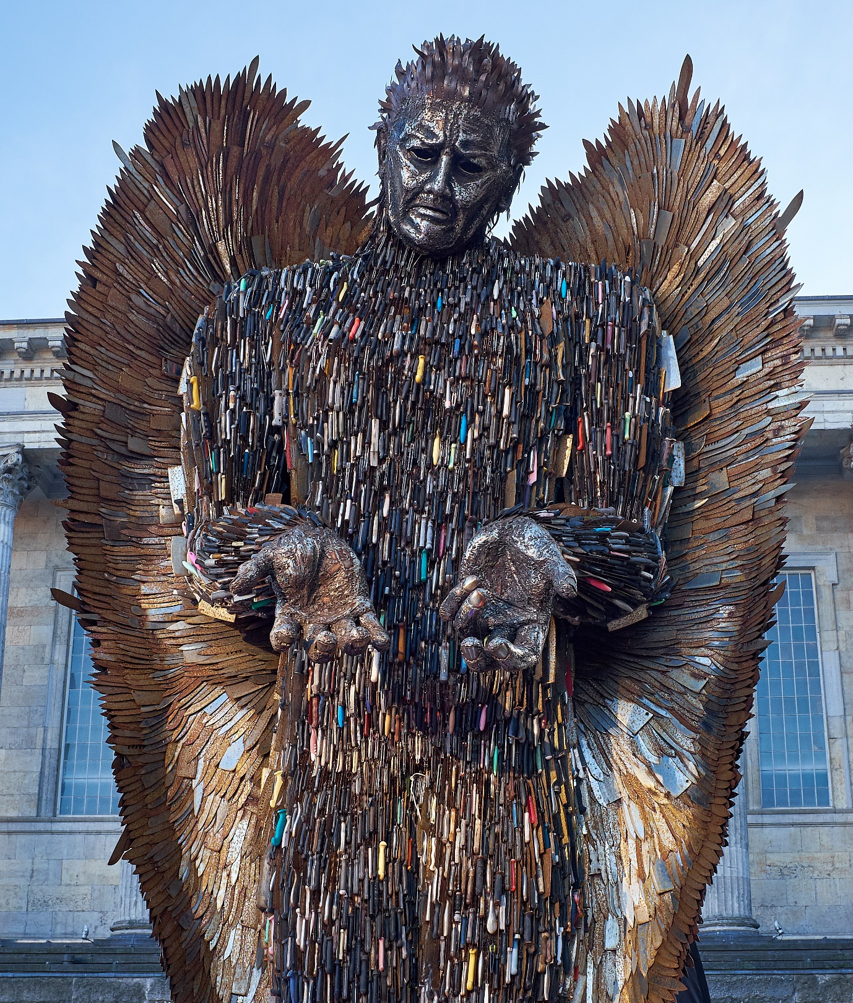

The Knife Angel by artist Alfie Bradley. Made from 100,000 knifes and weapons collected during a weapons amnesty – kitchen knives, flick knives, Samurai swords and martial arts weapons. Some of the wing blades are inscribed with the names of those lost to knife attack or injury.
Questions:
How does the Knife Angel make you feel?
What do the angel’s facial expression and hand gesture mean to you?
How does the knife angel link to the story of the good Samaritan?
Think about the poem and reflection below – how do they make you feel about the impact of violent crime on our city?
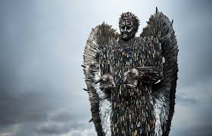
A Reflection While Standing Beneath the Knife Angel by Rev Larry Wright, Rector, Kings Norton Team Parish

… I see violence and strife in the city. Psalm 55:9

What message does this angel bring to the streets of our cities? It stands in isolation, constructed from thousands of knives, hands imploring and the face an expression of aching sorrow, it seems about to ask a question of all who pass by: “How long will this go on?” The posture could be one of prayerfulness and the question translated to a prayer: “O God come to our aid, O Lord make haste to help us.”

Those who pass by stare and take in this monumental figure, mostly without comment. Does the angel silence us into an uneasy mood of reflection? Do the thousands of knives remind us of the many wounds inflicted and the life blood of victims drained away? Do these blades, now harmless and transformed for another purpose, remind us of the heritage of Peace of which the prophet once spoke? “They shall beat their swords into ploughshares, and their spears into pruning-hooks; nation shall not lift up sword against nation, neither shall they learn war anymore.” (Isaiah 2.4).

Before weapons can be changed hearts must change first. The power of violence, when unleashed, and injury caused cannot be reversed. Violence breeds violence and bloodshed and death escalate and multiply. Another message needs to be heard; a call to peace and reconciliation, of hope and common humanity.

God of life,
Whose Son was cruelly wounded and slain
For the sake of a better world;
Transform our hatred to love,
Our hostility to friendship,
Our violence to peace.

AMEN

Sharpness
It was the sharpness of your voice
that got my attention
not the silver flash as you dipped and pulled.
There was no resistance,
my skin gave way immediately
and the
sharpness was quick
like a burst balloon
or a door slam.
And I spilled all over my hands
and feet
as you rummaged through
the bag,
angry that it wasn't
an Aladdin's cave,
and I watched with blurring eyes as you tossed it aside
and ran.
All sharpness washing away,
all light fading...

@jayetomas2019

Children’s activities
The ideas below focus on how we can be good neighbours through helping people, being kind, being good friends, fear and managing anger.
First aid bags – how can we give first aid to those around us? What could we put in our bag etc Decorate a paper bag and add in items such as sweets, plasters, tissues, a picture, a prayer card and hand them to people in your local community.
I can be kind – talk about ways we can be kind to each other. Make a voucher book for parents with things like hugs, pictures, smiles, jokes, tidying, helping. Make kindness confetti by drawing pictures and slogans on small pieces of paper and leaving them for people to find. Read together ‘Have you filled a bucket today?’ by Carol McCloud
Thank you or thinking of you cards – make cards and send them to people on your prayer list, people in your local community
Being helpful – how many times can you be helpful this week? Set your self a number as a challenge and add a sticker to your chart each time you help someone. Talk about how you can be helpful – picking up litter, saying thank you, putting away toys etc.
Fear – talk about knife and violent crime and people being hurt can frighten younger children. It may be useful to talk about fear in more general terms and what we can do if we are frightened.
Managing anger – create an anger ladder, starting with cool and calm blue at the bottom and changing through colours and moods to furious red at the top. Talk about things to do at each step of the ladder to stop things escalating. Create a ‘breathe box’ – a box with items in to help calm down – bubbles, stress balls, glitter bottles, playdoh, fidget toys. (many items can be purchased cheaply from budget shops)
Young People
Litter picks – litter picks are a great way of helping the local community. All that is needed is bin bags, rubber gloves and grabbers/litter pickers. A safety briefing is necessary so that young people understand what not to pick up with hands and the importance of wearing gloves. You may wish to separate litter into different bags for recycling.
Coping with fear and anger
Fear is like an iceberg. It is what we see, what causes it is what lies beneath the surface. Draw an iceberg and add descriptions above and below the sea to explain your worries and fears. Now do the same with anger. Talk about what you can do to help deal with these fears and anger – make a list of things to remember to help you cope with fear and deal with anger including breathing exercises, listening to music, talking to someone you trust, exercise, counting backwards, silly stories and so on.
It is important not to downplay or trivialise any fears or causes of anger discussed.

The Marshmallow Challenge
You will need enough large marshmallows so that each person can have two.
Give everyone one marshmallow.
Instructions:
You can eat the marshmallow now or if you can resist and not eat it for 15 minutes you will win a second marshmallow.
Set timer and see how people react. At the end of the set time hand out second marshmallows to those who managed to complete the challenge and discuss how people managed, what strategies they used and how they felt.
Good neighbours
How can we be good neighbours? How can we show service to others? Discuss ideas that young people can use such as offering to help with gardening or shopping, making and giving a gift or card to a local older person, making a treat bag for a young family.

Prayer
We are encouraging congregations to pray for Lives Not Knives. This could be personal prayer, as part of a service, at a location in your area where violent crime has taken place or as part of a prayer group. Here are a selection of prayers taken from a number of sources* for you to use.
Lives Not Knives Collect
Loving God, we choose to believe in hope.
Protect our city from violence.
Lead us to be good neighbours who work to turn
hostility into solidarity, fear into peace, hatred into hope
division into unity, and suffering into safety.
Amen

The Declaration of Hope
Today we choose to stand together as one.
We call for an end to violence and aggression in our city that causes division, despair and death.
We long for a shared future where our homes and streets are safe places again.
We declare that the power of love and forgiveness is stronger than the power of fear and revenge.
We will each play our part.
We will not be afraid.
Today we choose to believe in hope.

The litany of reconciliation
All have sinned and fallen short of the glory of God.
The hatred which divides nation from nation, race from race, class from class,
Father, forgive.
The covetous desires of people and nations to possess what is not their own,
Father, forgive.
The greed which exploits the work of human hands and lays waste the earth,
Father, forgive.
Our envy of the welfare and happiness of others,
Father, forgive.
Our indifference to the plight of the imprisoned, the homeless, the refugee,
Father, forgive.
The lust which dishonours the bodies of men, women and children,
Father, forgive.
The pride which leads us to trust in ourselves and not in God,
Father, forgive.
Be kind to one another, tender-hearted, forgiving one another, as God in Christ forgave you.
For the peace of the world
Almighty God, from whom all thoughts of truth and peace proceed:
Kindle, we pray, in the hearts of all, the true love of peace and guide with your pure and peaceable wisdom those who take counsel for the nations of the earth that in tranquillity your kingdom may go forward, till the earth is filled with the knowledge of your love; through Jesus Christ your Son our Lord.
Amen

For social justice and responsibility
Eternal God, in whose perfect realm
No sword is drawn but the sword of righteousness, and no strength known but the strength of love; so guide and inspire the work of those who seek your kingdom that all your people may find their security in that love which casts our fear and in the fellowship revealed to us in Jesus Christ our Saviour.
Amen

For our emergency services
Gracious God, we pray for our emergency services and hospital staff who deal with the aftermath of violence. Encourage and sustain them as they fight to bring an end to violence, to comfort the injured and those they love, and bring justice to our streets.
Amen

Talk and Listen
Churches are in a unique position to talk and most importantly, listen to young people – through our schools, children’s and youth groups, uniform groups and in church. This is an outline for a conversation with young people about violent crime further ideas can be found in this excellent resource:
https://noknivesbetterlives.com/?s=sharp+solutions
Begin by reassuring of safety and confidentiality (unless there is a safeguarding/risk situation). It is also important not to overreact or make judgement on comments that arise during the conversation.
Tell me what you know about knife and violent crime
What is a knife – what counts as a knife, what do you call it – slang terms
Do any of you carry a knife? Can you tell me why?
Do you know the consequences of being caught in possession of a knife? Talk about custodial sentences and criminal record – especially implications in 10/15 year time
Scenario – this young person (choose one, if possible use a white paper coverall and red pens to bring to life) is giving you verbal abuse. You are angry and have a knife. Where are you going to stab him that won’t cause serious damage? Is this realistic? You have stabbed him he is bleeding heavily – how are you going to stop the bleeding? (use first aid kits to role play). You can bleed to death in 4 minutes it takes an ambulance an average of 7 minutes to arrive.
Feedback: how did this make you feel? What could you do to stay safe? In the scenario where could you have changed the outcome and how?
Useful references:
https://www.gov.uk/buying-carrying-knives
https://safe.met.police.uk/knife_crime_and_gun_crime/consequences_and_the_law.html
http://www.sja.org.uk/sja/first-aid-advice/bleeding/severe-bleeding.aspx
https://www.west-midlands.police.uk/campaigns/life-or-knife
There are excellent television programmes with episodes featuring violent crime that can be used in discussion – 999:What’s your emergency? and 24 Hours in Police Custody.
Safe Spaces
Could your church become part of Safe Spaces?
Safe Spaces for Young People is a developing network of churches and Christian-led projects that provide Safe Spaces for young people to gather at the same time every week. The concept came from local youth workers wanting to resource and increase youth provision across the city.
For more information see appendix 2

Challenging the causes
Poverty
Find out more about poverty in your area and talk to your local councillors and MP about ways in which they are working to tackle this issue.
Food Poverty
Support your local foodbank by arranging collections and encouraging people to volunteer. Investigate the options of providing activities that provide food, especially during the school holidays.
Lack of youth work
Write to your local councillor, MP and the Prime Minister to raise the level of concern about the lack of youth work provision in the city.
Community action
Bleed kits
You may wish to explore purchasing a bleed kit for your local community. However, it is recommended that you liaise with your local police and other community organisations before purchasing it for the community. There are several issues with bleed kits that would need consideration:
- Access to the kit – where will it be kept?
- How to promote the location/availability of the kit
- Training is required in how to use the items in the kit
- Security of the kit

Further details of this initiative can be found at https://controlthebleed.org.uk/index.html
- Maintenance and security of the kit particularly as currently they are only available in a bag rather than a cabinet as in the case of defibrillators.

First Aid Training
Hold a first aid course for your local community so that more people are trained in how to provide vital first aid should an incident occur.

Blue Ribbons
Encourage everyone to display blue ribbons – wear them, put them on your car, in your window, on lampposts, in church. Add information that the ribbons are in memory of those killed an affected by violent crime.

Sources:
Common Worship: © The Archbishops’ Council 2000.
Declaration of Hope reproduced with kind permission from Coventry Cathedral
Knife Angel photograph reproduced with kind permission of David Ash Photography
Sharpness reproduced with kind permission of Jaye Thomas
Crime statistics from UK Crime Stats

